Diary Entry 7 Minecraft the race for diamonds

**7 .0 Introduction**

The team were required to develop a board game based upon a video game.  
  
**7.1 Materials**

|  |  |
| --- | --- |
| Material: | How the team used it: |
| Google doc | The team used google docs to create a simple layout for the game board (Figure 7.1) |
| 6D dice | The game, requires a 6 sided dice to play |
|  |  |

**7.2 The Rules**

The game the team came up with is based from the game “Minecraft”. In the game the first player to mine diamonds wins.

* The players start at the top right of the board and then roll a dice to see how many squares they can move.
* Once the player has moved they roll the dice again to see what material they collect, this depends on what square they on.
* The player gains cards depending on what resources they have so if they have 3 wood, they will have 3 wood cards.
* The player can then trade in these resource cards for other cards to progress in the game, for example you can trade in 4 wood to get 1 crafting table.

**4.3 Board and Game Cards**

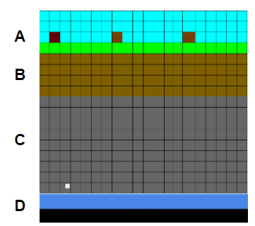

**Figure 7.1**, Mock-up game board.  [A] The tree level, [B]the dirt level, [C] the stone level, [D] Diamond level.

**Table 7.1** – A table showing the different cards

|  |  |  |
| --- | --- | --- |
| **Item** | **How to obtain it** | **Quantity** |
| Crafting table | Make with 4 wood | 4 (1 per player) |
| Furnace | Make with crafting table and 8 stone | 4 (1 per player) |
| Wooden Pickaxe | Make with crafting table and 5 wood | 4 (1 per player) |
| Stone Pickaxe | Make with crafting table, 2 wood, and 3 stone. | 4 (1 per player) |
| Iron Pickaxe | Make with crafting table, 2 wood, and 3 iron. | 4 (1 per player) |
| Wood | Mine with hands when on a tree block (rolling a 1-3 on a tree block) | 50 |
| Stone | Mine with wooden pick (rolling a 5 or 6 in a stone block) | 50 |
| Iron Ore | Mine with stone pick (rolling a 3, 4 in a stone block) | 15 |
| Iron | Smelt using a furnace, 1 coal, 1 iron ore | 15 |
| Coal | Mine with stone pick (rolling a 1,2 in a stone block) | 15 |
| Diamonds | Mine with a iron pick (rolling 1,2,3 in diamond area) | 1 |

**4.4 Play testing**

The team did external playtesting, the feedback we got was, “The game seems fun to play…”, “… Need to add enemies into the game so the player can die.” – Reece Taylour. The solution the team came up with was to add a chance for the player to die to lava when the player breaks a block in the rock layer, for future improvements the game could also have amour implemented into it so that when you are hit by lava you don’t die but lose your armour.

**4.5 Reflection**

The team worked very well together as we moved swiftly at the start and did not get hung up on the first ideas we come up with. To start we were going to do among us, then fall guys, then we decided on , Minecraft. Whilst coming up with the idea we had to simplify the game massively so that we could do play testing with in the time we had. This meant that we were able to create a game and play test it with in the time constraint. For future projects keep the mindset of getting a minable viable project is the correct mindset when having such short time to create a game in.

**4.6 Team Members and External Play Tester**

Team Members:

* Samiul Bari
* James Wilson
* Ali Noorani
* Will Connell

External Play Tester:

* Reece Taylour